**COURSEWORK SUBMISSION FORM**

|  |  |  |  |
| --- | --- | --- | --- |
| **STUDENT USE** | | **STAFF USE** | |
| Module Name | Business in its Environment | First Marker’s  (acts as signature) |  |
| Module Code | 3BUSS003C | Second Marker’s  (acts as signature) |  |
| Lecturer Name | Azizbek Allaberganov | Agreed Mark |  |
| UoW Student IDs |  | **For Registrar’s office use only (hard copy submission)** | |
| WIUT Student IDs | 00010384 |
| Deadline date | 16th of March, 2020 |
| Word count | 1880 |
| Assignment Type | 🗌Group ☑Individual |

**SUBMISSION INSTRUCTIONS**

**COURSEWORKS *must* be submitted in *both* HARD COPY (to the Registrar’s Office) *and* ELECTRONIC unless instructed otherwise.**

For hardcopy submission instructions refer to: [http://intranet.wiut.uz/Shared%20Documents/Forms/AllItems.aspx](http://charlotte.wiut.uz:36765/Shared%20Documents/Forms/AllItems.aspx) - Coursework hard copy submission instructions.doc

For online submission instructions refer to: [http://intranet.wiut.uz/Shared%20Documents/Forms/AllItems.aspx](http://charlotte.wiut.uz:36765/Shared%20Documents/Forms/AllItems.aspx) - Coursework online submission instructions.doc

|  |
| --- |
| **MARKERS FEEDBACK (Continued on the next page)** |
|  |

Table of contents

Introduction 3

Business purpose 3

Background 3

Role in Society 4

Internal Environment 4

Organizational Structure 4

Management 5

Rites and Rituals 6

Stakeholders 7

Employees 7

Customers 8

Government 8

Conclusion 9

Appendix 10

References 11

# Introduction

There are approximately 45-50 banks in Tashkent (uzbekistan.spr, 2019). This report will talk about one of these banks, “Uzpromstroybank”. The name of the bank is “O’zbekiston sanoat - qurilish bank” joint-stock commercial bank. Throughout the whole report will be analyzed topics such as how banks impact society, stakeholders, internal environment and external environment, organizational structure and management style. In the last part of the report, all mentioned information will be summed up as a conclusion.

# Business purpose The mission of the bank emphasizes the crucial role of the bank in the the economy of Uzbekistan and the special social role of the bank in society - maintaining confidence, reliability and stability in it.

## Background

Joint-Stock Commercial Bank “Uzbek Industrial Construction Bank” is one of the oldest financial in the Republic of Uzbekistan institutions and has been operating since 1922. Initially, the bank was called "Prombank". But in 1959, to strengthen financial control, Prombank was transformed into the bank for financing capital investments Stroybank. After the earthquake in 1966, the bank played an important role in the reconstruction of Tashkent. In 1987, the bank was renamed "Industrial Construction Bank" and in the same year, they began to improve the banking system. In 1991 was transformed into a joint-stock commercial bank. Finally, in 2018, the bank was rebranded. The bank changed its logo and began to strive for improvement even more. The Bank has 45 branches throughout Uzbekistan, and only 15 in Tashkent. The main branch is located in Tashkent, Yunusabad district, Shakhrisabz street, next to the Ucell office.

## Role in Society

JSCB "Uzpromstroybank" - a leading universal commercial bank Republic carries out large-scale investment activities for the development of basic sectors of the country's economy, small business, financing major investment projects involving foreign credit lines. “Uzpromstroybank” is the first in Uzbekistan to create a 24/7 regime, which allowed corporate clients to pay on their bills in the system Bank remotely at any time of the day: payments on customer accounts are made without the participation of bank executives, directly credited to the account the recipient; on any day of the week and time of day, customers can pay by settlement account of an economic entity in the 24/7 mode. “Uzpromstroybank” is the first in Uzbekistan to establish cooperation with the international organization Open Way, which is the creator of software for servicing plastic cards of international payment card systems. For individuals and legal entities innovative services, including international credit cards, virtual cards, corporate cards for legal entities, contactless payments using mobile applications using QR codes, the 3D Secure system in electronic commercial payments and bonus programs. The technology-based on the 3D Secure protocol is a unique system for ensuring the security of payment for goods and services on the Internet, which is part of the global programs Master Card Secure Code and Verified by Visa. By launching technology based on the 3D Secure protocol, the bank will provide the possibility of making safe online payments to their customers, as this protocol is designed to ensure the safety of purchases on the Internet due to additional customer identification.

# Internal Environment

## Organizational Structure

According to the information gathered, it can be said that the structure of the bank is tall. The chairman of the board leads the bank. In accordance with the respondent, there are approximately 400 workers in the head office. The composition of the board includes the deputy chairpersons of the board of directors, in addition to the chairperson, the chief accountant of the bank, as well as the heads of the main structural divisions (department and management) of the parent bank.  Along with the general management of banking, the Chairman of the Board directly supervises the Bank's Department, risk management department, legal department, executive control department, internal control department, human resources department, marketing department, information security and protection department, business analysis center, information service, First Division and Asset and Liability Management Committee. The internal audit department coordinates its activities. On behalf of the bank, signs guarantee and sureties. After him comes the first deputy chairman, he heads the strategic development department of the bank, the treasury department, the accounting and financial management department. According to the general directions and the main tasks for the coming year, the following divisions of the bank (departments and management) agreed to interact to achieve the goals: the Department of project management and execution control, the internal audit department, the Legal department, the Small business lending the department, the Risk management department, Department of accounting and reporting, Department of retail lending, Department of strategic development of the bank, Department of financial corporate customer service, Department of the Treasury, Department of Foreign Economic Affairs, Department of Banking and International Finance institutions, Retail Services Development Department, Internal Control Department, Information Security and Protection Department, Construction Department, Information Technology Department, Corporate Client Relations Department, Agricultural Lending Department, Human Resources Department, Training Center, Cash Operations Coordination Department.

## Management

Regarding the topic of management. Unfortunately, the interviewee did not have a strong idea about the management style in the bank itself. But despite this, the general idea was summarized. The opinion of each employee, starting from cashiers to managers will be taken into account when changing any rules. This suggests that the bank has a democratic leadership style. Once again, no one tells the workers what to do except their task. Excluding the ends of the month of course. At the end of each month, the number of clients served increases significantly, as loans are repaid by customers of the bank. If on ordinary days employees leave their workplace at 6-7 pm, then at the end of the month they are required to stay until late, as their task is to call all customers to pay off the loan.

## Rites and Rituals

In 2019, An event “Family Day” was held for “Uzpromstroybank” employees and their children in the capital's recreation and culture park “Ankhor - Lokomotiv”. The event was held in a festive spirit. In the park, under the fiery melodies with songs and dances, guests were greeted by fairy-tale characters. The opening program was opened by the Chairman of the Board of the Bank, Aziz Voitov, congratulating all employees on a wonderful day, wished them prosperity and happiness. “The love and support of your loved ones gives strength, inspires you to even more noble goals. Therefore, the focus of the leadership remains on the issues of social protection of your families, holding such entertainment events,” said the Chairman of the Bank's Management Board. Then the celebration continued with the launch of colorful balloons with the Bank's logo. Various competitions were held among parents and children - family karaoke, fun starts, dances, master classes. Guests were treated to a festive pilaf. In addition, in the same year a month later, an excursion to the head office of the bank was organized for the children of “Uzpromstroybank” employees. The purpose of the event contributes to the correct upbringing of the young generation in the spirit of patriotism, determination of the choice of a profession according to their interests, and finally, a close acquaintance of children with labor activity, the working conditions of their parents, which largely serves to strengthen friendly relations between them. The head office of the Bank was issued in accordance with the children's event. Children with music and dancing were met by various fairy-tale characters. At the beginning of the event, almost 200 children were presented with a cartoon on patriotic themes, then a video about the activities and history of the Bank. After which the guys, divided into groups, visited several structural divisions of the bank. In particular, in the cash operations department, children were met by cashiers and introduced them to the operation of the terminal, ATM and money transfer apparatus. The children were told about the types of plastic cards, the procedure for their use. They were taught the secrets of distinguishing real money from fake. In addition, the children learned a lot of interesting things about the benefits of deposits and deposit boxes and targeted loans. The young guests, getting acquainted with the working conditions of their parents, showed an increased interest in the security measures established by the bank, the operation of the turnstile and CCTV camera. The festive atmosphere of the event was given by the performance of the collective of the Uzbek State Theater of Musical Drama named after Mukimi, as well as various exciting quizzes. A festive tablecloth was served for the children, where they enjoyed ice cream. At the end of the event, the children were presented with colorful design plastic cards and gifts with the bank logo. In short, the excursion left a lasting impression on the children, as the organizers tried to make it one of the most striking events during the summer holidays.

# Stakeholders

## Madura defines the term “stakeholders” as “Every business involves transactions with people. Those people are affected by the business and therefore have a stake in it. They are referred to as stakeholders or people who have an interest (or stake) in the business”.

## Employees

## Bank employees with their diligence, honesty, punctuality and ability have a great influence on the further development of the Bank. For instance, in 2018, the HR department of “Uzpromstroybank” organized training for the heads of regional departments of the bank on the topic “Secrets of successful management: how to make employees go to work with pleasure”. During the training, participants were explained what the difference between a manager and a leader is, modern approaches to personnel management, maintaining a team spirit and motivation. The training was held under the slogan “Happy employee = happy customer”, which confirms that the positive emotional state of employees is extremely important for the employer. “Uzpromstroybank” equally values ​​both its customers and its employees and takes all measures to create comfortable conditions for both parties.

## Customers

Customers are one of the most important aspects in the development of the bank. Companies cannot survive without customers. To attract customers, the company must provide the desired products or services at an affordable price. You must also ensure that the goods or services produced are in order to ensure that customers are satisfied. If the company cannot offer the services or products at the fine and price that customers want, customers will switch to the competition of the company. For example, a bank holds various promotions for customers to attract their attention and separate from competitors.

## Government

Last but not least part of the stakeholder’s part is government.  in 2018, the head of our state gave instructions on the development of industry-based on innovation, studying foreign experience, improving productivity and competitiveness, and supported innovative projects of entrepreneurs. This was the reason why the Bank has become more competitive and continued to grow.

# Conclusion

According to this report, one can find out that “Uzpromstroybank” is one of the leading banks in Uzbekistan with several branches throughout the country. In this report, factors were mentioned as the goal of the business, the history of the bank, the role of the bank in the community, various holidays and traditions, and much more. Although the bank is one of the oldest banks in Uzbekistan, it is developing at a rapid pace due to support from the state, customers and society.

# Appendix

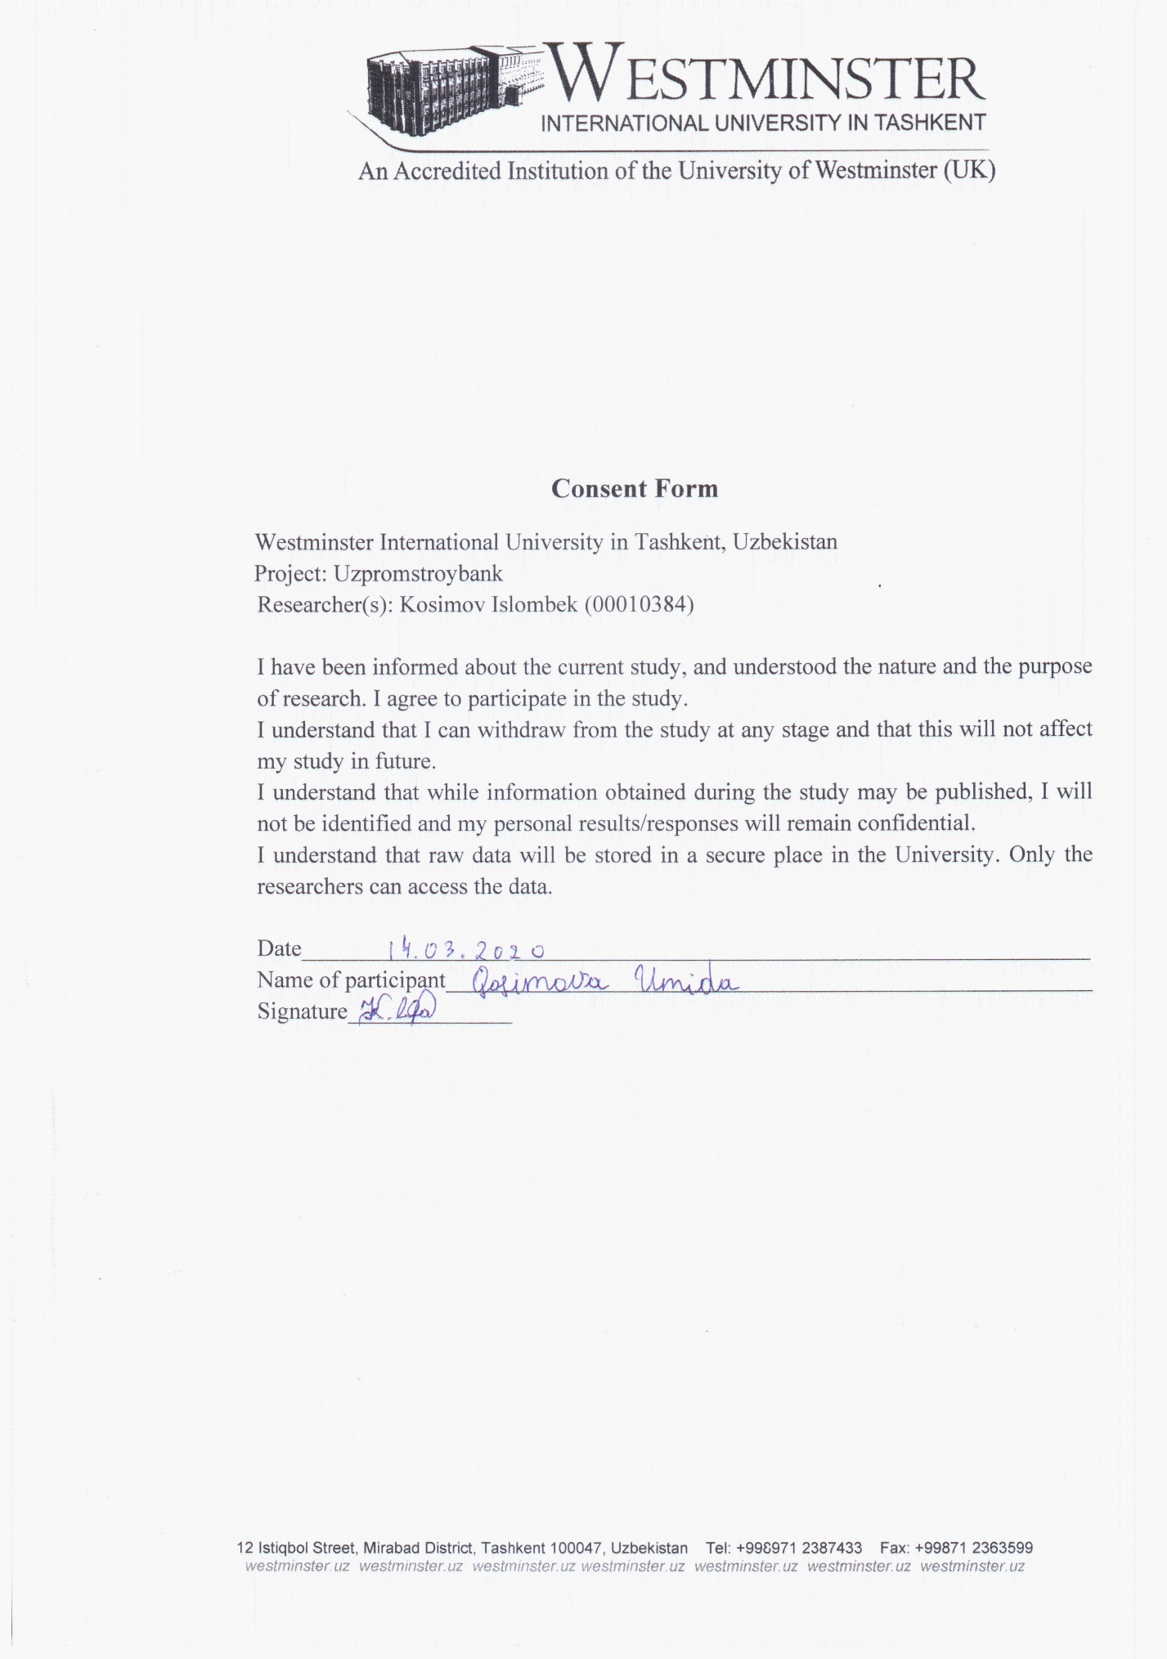

Tell us briefly about Uzpromstroybank.

How many branches in Tashkent?

Where is the head office?

What distinguishes your bank from other banks?

The role of the bank in society?

How many employees work in the head office?

What is the reason of promotion workers?

Does the bank have any traditions?

Organizational structure

What is the bank management style?

How do employees influence “Uzpromstroybank”?

How do customers influence “Uzpromstroybank”?

How does government influence “Uzpromstroybank”?

Interview:

https://drive.google.com/open?id=16j-BRWerL_OtYpENYq7O3qcOEfndDfdY

# References

Uzpromstroybank (2019). Bank Tarixi. *uzpsb*. Available from https://uzpsb.uz/uz/general-information/bank-tarixi/ [Accessed 14 March 2020].

uzbekistan.spr (2019). Банки в Ташкенте, отзывы, телефоны и адреса на карте Ташкента. *uzbekistan.spr.ru*. Available from https://uzbekistan.spr.ru/tashkent-i-tashkentskiy-gorodskoy-okrug/banki/ [Accessed 14 March 2020].

Uzpromstroybank (2019). Филиалы. *Uzpsb.* Available from https://uzpsb.uz/filials/ [Accessed 15 March 2020].

Uzpromstroybank (2019). Бизнес-план. *uzpsb*. Available from https://uzpsb.uz/for-investors/biznes-plan/ [Accessed 15 March 2020]

Uzpromstroybank (2019). O‘zsanoatqurilishbank jamoasi uchun “Oila kuni” aksiyasi o‘tkazildi. *uzpsb*. Available from https://uzpsb.uz/uz/press-center/newsuz/o-zsanoatqurilishbank-jamoasi-uchun-oila-kuni-aksiyasi-o-tkazildi/?sphrase_id=35836 [Accessed 16 March 2020].

Uzpromstroybank (2018). Президент поддержал инновационные проекты. uzpsb. Available from https://uzpsb.uz/press-center/news/prezident-podderzhal-innovatsionnye-proekty/?sphrase_id=35851 [Accessed 16 March 2020].

Uzpromstroybank (2019c). Познавательная экскурсия для детей в Узпромстройбанк. *uzpsb*. Available from https://uzpsb.uz/uz/press-center/news/dlya-detey-organizovana-ekskursiya-v-bank/?sphrase_id=35837 [Accessed 16 March 2020].

Uzpromstroybank (2018). “Секреты успешного управления: как сделать так, чтобы сотрудники ходили на работу с удовольствием.” *uzpsb*. Available from https://uzpsb.uz/uz/press-center/news/sekrety-uspeshnogo-upravleniya-kak-sdelat-tak-chtoby-sotrudniki-khodili-na-rabotu-s-udovolstviem/?sphrase_id=35838 [Accessed 16 March 2020].

Madura, J., Hoque, A. and Chandrasekhar Krishnamrti (1994). International financial management, 4th ed. South Melbourne, Australia: Cengage Learning Australia, 62.